
Chair of Metal Forming and Casting
Department of Mechanical Engineering
Technical University of Munich

Application of CNN on
Crystal Plasticity for
Material Modelling
—
Department of Aerospace Engineering
Term Paper
Betreut von/Supervisor
Lukas Martinitz
Chair of Metal Forming and Casting

Eingereicht von/Submitted by
Pradeepti Shekhar
Matriculation number - 03752122

Eingereicht am/Submitted on
20.12.2023


I hereby declare that this thesis is entirely the result of my own work except where otherwise indicated. I have only used the resources given in the list of references.
München, 20/12/2023
ABSTRACT
The Aerospace field relies heavily on structures that have excellent mechanical and thermal properties with fatigue resistance and high fracture toughness. This leads to a significant use of Anisotropic Materials including alloys and composites in the manufacturing of Aircrafts and Satellites.
Anisotropic Materials have physical properties that depend on the direction of measurement for e.g., Young’s Modulus, yield strength, creep rate, etc. Carbon Fiber-Reinforced Polymers (CFRP) are used in wings and fuselage due to their high strength to weight ratio, Kevlar has high tensile strength and is therefore used in space shuttles to protect against impact from orbital debris. Aluminium alloys are also used extensively in aeroplanes because of their high strength-to-weight ratio, corrosion resistance and low cost.
Since anisotropy is complex and the properties are crystal structure dependent, Crystal Plasticity Theory is used to understand and determine the micro-scale deformation of metals. According to Crystal plasticity theory, deformation occurs through the motion of dislocation in a slip system. This theory also provides the stress-strain relationship of the grains in a crystal.
However, determination of anisotropic properties through crystal plasticity theory requires high computational costs and effort. To combat this problem, this paper aims at determining the properties of a AA5083 polycrystal by feeding information obtained from crystal plasticity simulations in DAMASK to a Convolutional Neural Network. The ability of neural networks to understand complex relationships between features and predict the desired output with high accuracy would contribute significantly in reducing the challenges associated with crystal plasticity simulations.
The CNN model is trained to predict stresses and new orientations produced due to deformation gradients applied on the Representative Volume Element (RVE), while also preserving the relative position of grains. The model is evaluated by calculating the Root Mean Squared Error (RMSE) for stresses and Mean Absolute Error (MAE) for orientations. <End with results and conclusions>

NOMENCLATURE
Abbreviations
RVE | Representative Volume Element
DAMASK | Düsseldorf Advanced Material Simulation Kit
FCC | Face Centered Cubic
BCC | Body Centered Cubic
HCP | Hexagonal closed packed
CP | Crystal Plasticity
CPFEM | Crystal Plasticity Finite Element Method
CPFFT | Crystal Plasticity Fast Fourier Transform
ML | Machine Learning
AI | Artificial Intelligence
CNN | Convolutional Neural Network
RNN | Recurring Neural Network
FNN | Feed Forward Neural Network
DNN | Deep Neural Network
FC layer | Fully Connected Layer
HDF | Hierarchical Data Format

Variables and constants
F | Deformation Tensor
$$\tilde{L}$$ | Spatial Velocity Gradient
E | Lagrangian Tensor
σ | Cauchy Stress
t | Traction
𝜏 | First Piola-Kirchoff stress
J | Jacobian of deformation
𝑆 | Second Piola-Kirchoff Stress
$$γ$$ | Deformation increase
𝐷 | Stretching
𝛺 | Spinning
$F^{p}$ | Plastic part of deformation
$$F^{*}$$ | Elastic part of the deformation gradient.
$$τ_{α}$$ | resolved shear stress
K | Elastic moduli tensor
L | Modified elastic Tensor
𝑥𝑖 | input features
𝜔𝑖 | weights
𝑏 | bias
tanh(x) | Tangent hyperbolic function of x

Contents
1 Introduction 1
1.1 Motivation of the work 1
1.2 Objective 1
1.3 Structure of the work 1
2 State of the Art 2
2.1 Polycrystal 2
2.2 Continuum mechanics 3
2.3 Large Deformation Kinematics 3
2.3.1 Strain 4
2.3.2 Stress 4
2.4 Crystal Plasticity Theory 5
2.4.1 Crystal Plasticity Kinematics 6
2.4.2 Plastic Deformation 9
2.4.3 Elasticity 9
2.4.4 Overall Constitutive Law 9
2.4.5 Application of Crystal Plasticity 10
2.5 Machine Learning 11
2.5.1 Neural Networks 11
2.5.2 Deep Neural Networks 12
2.5.3 Convolutional Neural Network 13
3 Methodology 16
3.1 Data Generation 16
3.2 Data Extraction 16
3.2.1 Initialization 16
3.2.2 Data Processing Loop 17
3.2.3 Subsequent Increments 17
3.2.4 Data Storage 17
3.3 Data Pre-Processing 17
3.4 CNN Model 17
3.4.1 Dataset Handling 17
3.4.2 Neural Network Architecture 18
3.4.3 Hyperparameters 18
3.4.4 Activation function 18
3.4.5 Training and Validation 18
3.4.6 Optimization 19
3.4.7 Evaluation criteria 19
3.5 Experiments 19
3.5.1 Hyperparameter tuning 19
3.5.2 Addition of layers 20
4 Results and Discussion 20
4.1 Initial Architecture 20
4.1.1 Lr = 0.01, batch size =128, Number of epochs =10 20
4.1.2 Lr = 0.005, batch size =128, Number of epochs =10 22
4.1.3 Lr = 0.01, batch size =128, Number of epochs =20 23
4.2 Changing Train- Validation Data Split 24
4.2.1 Lr = 0.01, batch size =128, Number of epochs =15 24
4.2.2 Lr = 0.01, batch size =128, Number of epochs =25 25
4.2.3 Lr = 0.01, batch size =128, Number of epochs =50 26
4.3 Addition of Max Pooling Layer 27
4.4 Addition of Dropout Layer 28
4.4.1 Lr = 0.01, batch size =128, Number of epochs =15 28
4.4 Discussion 29
5 Conclusion 31
List of Figures 32
References 33

1 Introduction

Motivation of the work
Material selection is an important part of manufacturing process. To choose the correct material, properties of different materials need to be determined so as to find the material that best suits the criteria defined by the application. The science of determining material properties is called Material Modelling.
A common way of modelling materials is by performing computational simulations to understand the behaviour of materials under loading. However, computational simulations of crystal plasticity to determine mechanical behaviour of anisotropic materials is expensive.
This paper aims at combining crystal plasticity theory and Machine learning by using Convolutional Neural Networks to predict the behaviour of anisotropic metals. The broader goal is to contribute towards developing neural network models that can be used as a replacement for computational simulations

Objective
Computational simulations were carried out on a 50 grain AA5083 RVE which is an aluminium alloy commonly used in aerospace structures. The element was subjected to different types of loading and the information obtained through crystal plasticity simulations over the grain in DAMASK was stored in HDF5format. The data from the DAMASK simulations contains the deformation gradient, orientations, slip resistance and stresses produced in each grain in the RVE for each time increment in each state.
The objective of this paper is to obtain useful information from the DAMASK simulations namely, deformation gradient, orientations and stresses produced for each time increment of a state such that it represents the crystal structure of the RVE. This dataset is then fed through the CNN based on PyTorch to create a model that can replicate the relationship between the deformation gradient and stresses produced due these deformation gradients while also taking into account the orientation of each grain.

Structure of the work
The term paper is divided into 5 sections. The first section, State of the Art, gives the background information related to the project which includes a basic understanding of Crystal Plasticity theory and Machine Learning. The second section, describes the problem statement and the implementation of the experiment and the tools used. This is followed by the Results and Discussion section that contains the result of the experiment and its interpretation. At the end, there is a Conclusion section which includes the feasibility of the experiment and future enhancements needed.

State of the Art

Polycrystal
Polycrystalline materials are solid structures comprised of numerous tiny crystals known as "grains." These grains are delineated by grain boundaries and typically exhibit random crystallographic orientations. Polycrystals are made of aggregates of single crystal grains, which make up the RVE. (1)

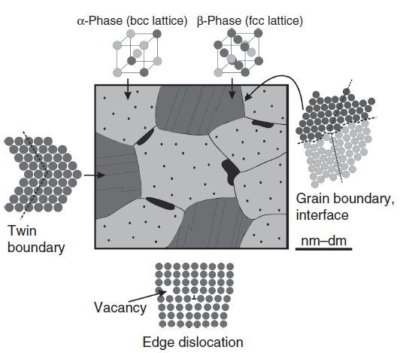
Figure 1 Schematic of a Polycrystalline metallic material. The grain boundaries act as interface between grains. The movement of grains cause vacancies and atomic defects. Adapted from Microstructure and Properties of Engineering Materials Helmut Clemens, SveaMayer, and Christina Scheu.
Some important features of a polycrystal material are:

- Grain Boundaries: These are the boundaries that exists between neighbouring grains in a polycrystalline material is referred to as a grain boundary. Within these boundaries, there are alterations in crystallographic orientation, causing disturbances in the usual atomic arrangement. The characteristics of these boundaries have the potential to impact the material's overall mechanical, thermal, and electrical properties. Grain boundaries prevent the movement of dislocations and causing a strengthening effect. (2)

- Processing and Formation: Polycrystalline materials commonly form due to manufacturing techniques like casting, sintering, or powder metallurgy. In these procedures, grains nucleate and develop autonomously, giving rise to an intricate microstructure composed of numerous grains and boundaries.

- Mechanical Properties: The mechanical properties of polycrystalline materials are significantly different from mechanical properties of monocrystal materials. Grain boundaries oppose the movement of dislocations, thus affecting the strength, ductility, and deformation behaviour of the material. Hardness and fracture toughness are also affected by the number of grains. The grain boundaries accord higher strength and hardness to polycrystals than that of single crystals. The finer the crystal grains in polycrystals, the larger the ratio of grain boundary regions and the strength and hardness of metals and alloys. (3)

- Anisotropic Properties: Polycrystalline materials can be anisotropic, i.e., their mechanical and thermal properties may depend on the direction in which they are measured. The difference in crystallographic orientations of individual grains give rise to anisotropy.

- Grain Size: The size of each individual grains in a polycrystalline material also affects its properties. Increased strength and hardness are observed in fine grained materials as compared to coarse-grained materials.
Understanding the characteristics of polycrystalline materials is crucial for materials scientists and engineers engaged in the development and enhancement of materials, as the microstructure plays a pivotal role in shaping the overall performance and properties of the material.

Continuum mechanics
Continuum mechanics is based on the concept of a homogeneous continuum, which can be repeatedly subdivided into infinitesimal sub volumes, each of which retains the properties of the bulk material. (4)

Large Deformation Kinematics
Large deformation kinematics is used to define the deformation of a material when it changes from a reference state to a deformed state. In the following figure, the vector x represents the position of a material point in the initial configuration, while the vector y(x) denotes the position of the same point in the present configuration. The displacement vector for this point is expressed as u(x) = y(x) - x. The velocity vector for the material point is given by v(x) = du/dt, and the current configuration's surface traction distribution is denoted by t.
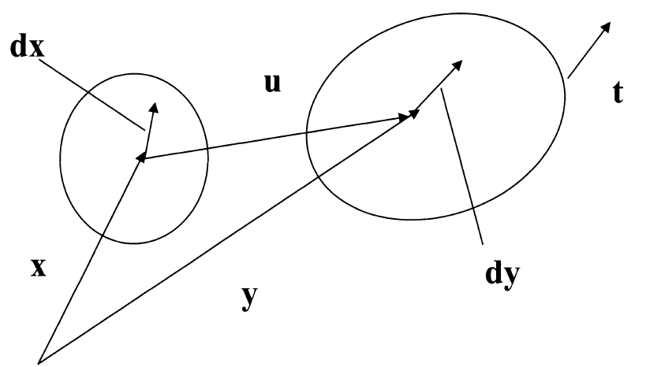
Figure 2 Finite Deformation Kinematics adapted from Microstructure and Properties of Engineering Materials Helmut Clemens, SveaMayer, and Christina Scheu.
The following derivation is taken from Microstructure and Properties of Engineering Materials by Helmut Clemens, SveaMayer, and Christina Scheu.
Let us take an infinitesimal material fibre defined by dx in the reference configuration and by dy in the deformed configuration. The deformation tensor F relates the reference and current configuration by
$ⅆy=F⋅ⅆx⇔F=\frac{∂y}{∂x}=∇y⇔F_{i\dot{j}}=\frac{∂y_{i}}{∂x_{j}}=y_{ij}$ (1)
and the spatial velocity gradient is defined by
$\tilde{L}=\dot{F}⋅F^{-1}$. (2)

Strain
Consider the change in magnitude of dx due to stretching. The derivation is adapted from Microstructure and Properties of Engineering Materials by Helmut Clemens, SveaMayer, and Christina Scheu.

$$\left|ⅆy^{2}\right|-\left|ⅆx^{2}\right|=\left(F⋅ⅆx\right)⋅\left(F⋅ⅆx\right)-ⅆx⋅ⅆx$$
$$=ⅆx⋅\left(F^{T}⋅F\right)ⅆx-ⅆx⋅ⅆx$$
$=ⅆx\left(F^{T}⋅F-I\right)⋅ⅆx$
$=2ⅆx⋅E⋅ⅆx$ (3)
Where E is the Lagrangian tensor.
$$E=\frac{1}{2}\left(F^{T}⋅F-I\right)$$ (4)
It is evident that the relationship between strain and displacement gradient is non-linear.

2.3.2 Stress
Cauchy stress (σ) is the force per unit area in the deformed configuration. It is defined as traction t on a surface per unit normal vector to the surface $\tilde{n}$.
$$σ=\frac{t}{\tilde{n}} ( SEQ Equation \backslash * ARABIC 5)$$
Piola- Kirchoff stresses are pseudo stresses. The first Piola-Kirchoff stress is given by
$τ=Jσ ( SEQ Equation \backslash * ARABIC 6)$
where J is the jacobian of the deformation.
The second Piola-Kirchoff stress is represented by S,
$S=F^{-1}τF^{-T}$ ($SEQ Equation \backslash * ARABIC 7)$

2.4 Crystal Plasticity Theory
The primary physical process causing plastic deformation at room temperatures involves the movement of dislocations along crystal slip systems. This dislocation motion does not lead to any overall compression or expansion of the crystal lattice, ensuring that plastic deformation maintains volume. Once the dislocation has traversed through, the lattice returns to an undistorted state.
Slip systems refer to closely packed atomic directions on similarly closely packed atomic planes. This configuration results in the smallest magnitude of dislocation Burgers vector, making it the most favourable direction for slip. Some basic crystal structures and major slip systems are (indicated by their Miller Indices) are as follows (5):

• FCC- AI, Cu, Ni, y-Fe- <1 1 1>{1 1 0}
• BCC-a-Fe,o-Fe,Cr,Mo-<11 0>{1 1 1}
• HCP-Mg,Zn-<0001>{1 1-1 0}
A significant consequence of crystallographic slip is the rotation of the crystal lattice, a result of the finite deformation associated with extensive dislocation flow. This phenomenon is depicted in Figure 3, where an idealized single crystal specimen with a single active slip system is subjected to tensile loading. The finite deformation during slip generates an unbalanced moment, necessitating the rotation of the specimen and, consequently, the lattice, to restore equilibrium. This rotation induces bending stresses at the supports due to the imposed constraints. In a broader context, it can be stated that lattice rotation is geometric in nature, and it does not need to occur uniformly across the entire crystal; it may be constrained in specific locations, leading to the generation of stresses.
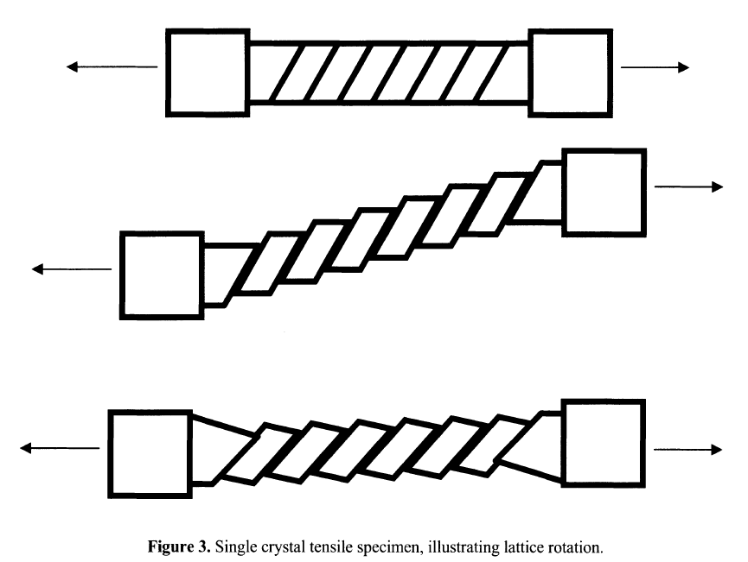
Figure 3 Lattice rotation in a single crystal tensile specimen adapted from Microstructure and Properties of Engineering Materials Helmut Clemens, SveaMayer, and Christina Scheu.

2.4.1 Crystal Plasticity Kinematics
Crystal Plasticity theory is considered a physical based theory as it is based on the behaviour of microstructures in a material. In crystal plasticity theory, flow of massive dislocation in a slip system are represented as a plastic shear strain y in a continuum sense, where the slip plane normal is represented by the unit vector m and direction of the slip by unit vector s.
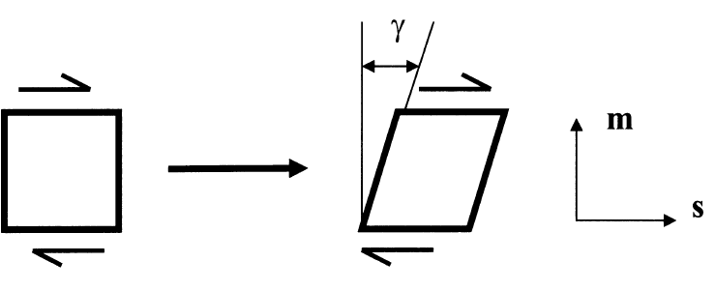
Figure 4 Plastic shear strain on a slip system adapted from Microstructure and Properties of Engineering Materials Helmut Clemens, SveaMayer, and Christina Scheu.
This plastic shear strain can be related to deformation and strain through tensorial representation. To achieve this, under the assumption of small strain kinematics, let there be a material point x within a crystal and a material fibre dx, in the reference configuration. (5)
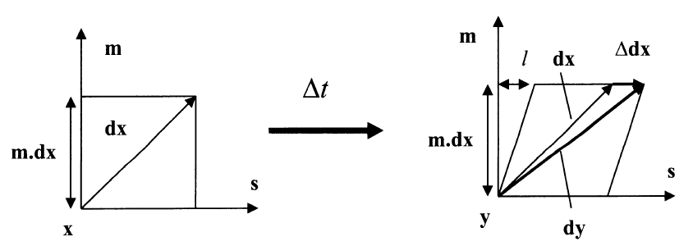
Figure 5 Kinematics of deformation of crystal adapted from Microstructure and Properties of Engineering Materials Helmut Clemens, SveaMayer, and Christina Scheu.
An increase in deformation, resulting from shear movement on a slip system by an amount Δ γ over a time Δ t, leads to the displacement of the material point at x to y. Subsequently, the fiber is now defined by dy, while the stretching and rotation of the fiber are represented by Δ dx.
The following derivation is taken from Microstructure and Properties of Engineering Materials by Helmut Clemens, Svea Mayer, and Christina Scheu.
$$\frac{l}{m⋅ⅆx}=Δγ=\dot{γ}Δt ( SEQ Equation \backslash * ARABIC 8)$$
$$l=\dot{γ}Δtm⋅ⅆx ( SEQ Equation \backslash * ARABIC 9)$$
but we know,
$l=\left|Δⅆx\right|$ ($SEQ Equation \backslash * ARABIC 10)$
$\left|ⅆx\right|=\dot{γ}Δtm⋅ⅆx$ ($SEQ Equation \backslash * ARABIC 11)$
Now,
$Δⅆ\left|Δⅆx\right|s$($SEQ Equation \backslash * ARABIC 12)$
$$Δⅆx=\dot{γ}Δts\left(m.dx\right)$$ | ($SEQ Equation \backslash * ARABIC 13)$
$$\frac{Δⅆx}{Δt}=\dot{γ}s\left(m⋅ⅆx\right)$$ | ($SEQ Equation \backslash * ARABIC 14)$
$$\lim_{Δt→0}\frac{Δⅆx}{Δt}=ⅆ\dot{x}$$ | ($SEQ Equation \backslash * ARABIC 15)$
Therefore,
$$ⅆ\dot{x}=\dot{γ}s\left(m⋅ⅆx\right)$$ | ($SEQ Equation \backslash * ARABIC 16)$

The equation can be written as
$ⅆ{\dot{x}}_{i}=\frac{∂{\dot{x}}_{i}}{∂x_{j}}ⅆx_{j}$ | ($SEQ Equation \backslash * ARABIC 17)$

Differentiating using chain rule,
$\frac{ⅆ{\dot{x}}_{i}}{ⅆx_{j}}=\frac{∂{\dot{x}}_{i}}{∂x_{j}}ⅆ{\dot{x}}_{j}=\dot{γ}s_{i}m_{j}ⅆx_{j}$ | ($SEQ Equation \backslash * ARABIC 18)$

For arbitrary $ⅆx_{j} values we have,$
$$\frac{∂{\dot{x}}_{i}}{∂x_{j}}=\dot{γ}s_{i}m_{j}$$ | ($SEQ Equation \backslash * ARABIC 19)$
The left-hand side of the equation represents velocity gradient $\tilde{L}$
$${\tilde{L}}_{ij}=\dot{γ}s_{i}m_{j}$$ | ($SEQ Equation \backslash * ARABIC 20)$

Converting this to tensor form,
$\tilde{L}=\dot{γ}sm$ | ($SEQ Equation \backslash * ARABIC 21)$

The velocity gradient gives both stretching rate and spinning rate.
The same method can be used to get the deformation of a crystal going from a deformed state $y_{t}$at time t to an increased deformed state $y_{t+Δt}$ at time $t+Δt$.
$$ⅆ\dot{y}=\dot{γ}s\left(m⋅ⅆy\right)$$ | ($SEQ Equation \backslash * ARABIC 22)$
$$ⅆ{\dot{y}}_{i}=\dot{γ}s_{i}m_{j}ⅆy_{j}$$ | ($SEQ Equation \backslash * ARABIC 23)$
$$\frac{∂{\dot{y}}_{i}}{∂y_{j}}={\tilde{L}}_{ⅈj}=\dot{γ}s_{i}m_{j}$$ | ($SEQ Equation \backslash * ARABIC 24)$
$$\tilde{L}=\dot{γ}sm$$ | ($SEQ Equation \backslash * ARABIC 25)$

where, $\tilde{L}$is the spatial velocity gradient.
According to Continuum mechanics, the deformation gradient is given by
$F=\frac{∂y}{∂x}$ | ($SEQ Equation \backslash * ARABIC 26)$
$$\tilde{L}=\frac{∂\dot{y}}{∂y}=\frac{∂\dot{y}}{∂x}\frac{∂x}{∂y}=\dot{F}⋅F^{-1}$$ | ($SEQ Equation \backslash * ARABIC 27)$

This is broken down into symmetric and non-symmetric components, stretching and spinning, respectively.
$D=\frac{1}{2}\left(\tilde{L}+{\tilde{L}}^{T}\right)$ | ($SEQ Equation \backslash * ARABIC 28)$
$$Ω=\frac{1}{2}\left(\tilde{L}-{\tilde{L}}^{T}\right)$$ | ($SEQ Equation \backslash * ARABIC 29)$
where D is strain rate (rate of deformation tensor) and Ω is the plastic spin tensor.
A single slip would be represented by
$$F=\left[\begin{matrix}1 & γ \\ 0 & 1\end{matrix}\right]⇒τ=\left[\begin{matrix}0 & \dot{γ} \\ 0 & 0\end{matrix}\right]⇒D=\left[\begin{matrix}0 & {\dot{γ}}/2 \\ {\dot{γ}}/2 & 0\end{matrix}\right], Ω= \left[\begin{matrix}0 & {\dot{γ}}/2 \\ -\left({\dot{γ}}/2\right) & 0\end{matrix}\right]$$
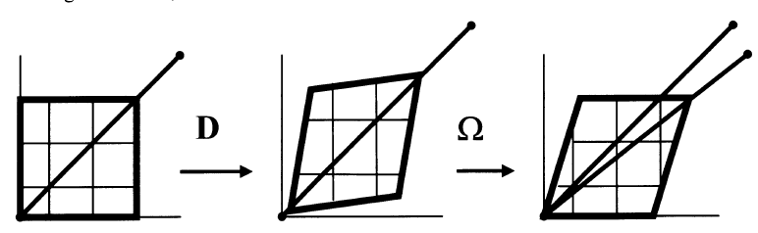
Figure 6 Kinematics of Crystal Deformation, Stretching and Spinning adapted from Microstructure and Properties of Engineering Materials Helmut Clemens, SveaMayer, and Christina Scheu.
For n slip systems with α active points
$$\tilde{L}=D+Ω_{plastic}=\sum_{α=1}^{n}{{\dot{γ}}_{a}s_{α}m_{α}}$$ | ($SEQ Equation \backslash * ARABIC 30)$

Now, plastic deformation is combined with elastic and rigid body deformation through multiplicative decomposition of the deformation gradient F,
$$F=F^{*}⋅F^{p}$$ | ($SEQ Equation \backslash * ARABIC 31)$

Where, $F^{p}$ is the plastic part of deformation gradient and $F^{*}$ is the elastic part of the deformation gradient.
From this we understand that in this process, starting from the reference configuration, plastic flow induces deformation through the lattice without altering the lattice itself until an intermediate configuration is attained. Subsequently, elastic deformation and rigid body motion of the lattice and its enclosed material takes place, leading to the final or current configuration. It is important to note that, in reality, both types of deformation typically happen concurrently.
The second Piola- Kirchoff Stress S and the Lagrangian Strain Tensor E can be defined on the reference state.
$$S=F^{-1}τF^{-T} and E=\frac{1}{2}\left(F^{T}⋅F-I\right)$$ | ($SEQ Equation \backslash * ARABIC 32)$
Similarly, on the intermediate configuration, S* and E* can be defined as
$$S^{*}=F^{*-1}τF^{*-T} and E^{*}=\frac{1}{2}\left(F^{*T}⋅F^{*}-I\right)$$ | ($SEQ Equation \backslash * ARABIC 33)$

2.4.2 Plastic Deformation
Plasticity is a crystal property. Plasticity occurs because the slip system shear stress causes slip system shear strain in the crystal, $τ_{α}⇒{\dot{γ}}_{α}$. The movement of crystal lattice causes the slip systems to move, this deformation is described by F*. It is understood that $m_{α}$ and $s_{α}$leads to $m_{α}^{*}$ and $s_{α}^{*}$ in the current configuration, where $s_{α}^{*}=F^{*}s_{α}$ and $m_{α}^{*}=F^{*-T }m_{α}$.
The resolved shear stress is given by
$τ_{a}=m_{α}^{*}⋅τ⋅s_{α}^{*}$ | ($SEQ Equation \backslash * ARABIC 34)$

2.4.3 Elasticity
Stresses produced in a crystal depend solely on the elastic deformation of the crystal. In the intermediate form, this can be represented by
${\dot{S}}^{*}=K:{\dot{E}}^{*}$ | ($SEQ Equation \backslash * ARABIC 35)$
Where K is the elastic moduli tensor.

2.4.4 Overall Constitutive Law
The Overall Constitutive Law can be formed on either the reference configuration or the deformed configuration. Using the reference configuration, the quantities and their time derivatives on the axes of rotation can be ignored.
After differentiating and combining the equation 32 and equation 33, the following equation is obtained
$${\dot{E}}^{*}=F^{p-T}⋅\dot{E}⋅F^{p-1}-\sum_{α=1}^{n}{{\dot{γ}}_{α}A_{α}}$$ | ($SEQ Equation \backslash * ARABIC 36)$

$$A_{α}=sym\left\{F^{*T}⋅F^{*}⋅s_{α}m_{α}\right\}$$ | ($SEQ Equation \backslash * ARABIC 37)$
Combining the stresses and differentiating,
$${\dot{S}}^{*}=F^{p}⋅\dot{S}⋅F^{pT}+2\sum_{α=1}^{n}{{\dot{γ}}_{α}B_{α}}$$ | ($SEQ Equation \backslash * ARABIC 38)$
where $B_{α}=sym\left\{s_{α}m_{α}S^{*}\right\}$
Substituting the stress and strain tensor rate into the elastic rate equation, the final equations are obtained
$$\dot{S}=L:\dot{E}-\sum_{α=1}^{n}{{\dot{γ}}_{α}x_{α}}$$ | ($SEQ Equation \backslash * ARABIC 39)$
$$X_{α}=F^{p-1}⋅R_{α}⋅F^{p-T}$$ | ($SEQ Equation \backslash * ARABIC 40)$

$$R_{α}=K:A_{α}+2B_{α}$$ | ($SEQ Equation \backslash * ARABIC 41)$
where L is the modified elastic moduli tensor.

2.4.5 Application of Crystal Plasticity

2.4.5.1 Microscale Approach
The abovementioned Crystal plasticity theory can be used in Finite Element analysis to observe and study deformation in monocrystals and polycrystals at microscale. This field of study is called Crystal Plasticity Finite Element method (CPFE).
CPFE has been used to understand the anisotropic behaviour of a commercially pure Titanium Grade 1 sheet upon different strain paths by Takayuki Hama, et al,. (6) The study delved into the understanding the mechanism of anisotropic deformation, with a specific emphasis on understanding the influence of twinning activity in plastic deformation. The research revealed that twinning activity played a crucial role in shaping certain features, including anisotropies in the Lankford value and work hardening during compression, as well as tension-compression asymmetries in the stress-strain curves along the rolling direction. Furthermore, the detwinning activity was found to impact stress-strain curves during reverse loading, particularly in the rolling direction.
Preitang Wei, et al, studied the Anisotropic Plastic Behaviour in High Pressure Torsion of an Aluminium Single Crystal by using CPFE method. (7) They observed the crystallographic orientation evolution along the tangential direction to predict the corresponding lattice rotation and slip trace. The results of the simulation indicated that the anisotropic plastic deformation observed in HPT is attributed to variations in the activation of slip systems, including dominant slip and multiple slips.

2.4.5.2 Macroscale Approach
CP is used to develop constitutive model of polycrystal aggregates. It is used to predict the deformations caused by changes in alignment of crystal lattices, from random orientations in a reference state to well-formed orientations in the deformed state. These deformations lead to anisotropic behaviour in the material at macroscopic level.
Takayuki Otsuka, et al, used CP with Fast Fourier Transform scheme to solve transformation plasticity and analyse texture development by deformation. (8) FFT was used instead of FEM because it uses significantly less computer resources to perform mathematical operations while also being capable of large-scale analyses The results showed that when the strain rate sensitivity exponent (m-value) is smaller, then the strain rate dependency is smaller, which is the characteristic of constitutive law.

2.4.5.3 Multiscale Approach
The multiscale approach combines molecular dynamics and CP theory. Pandong Lin, et al, (9) used atomic scale parameters to introduce absorption probability in the crystal plasticity framework. The mechanical behaviour of irradiated body-center-cubic (BCC) A508-3 steel was analysed using the evolution equations for partial- and full-absorption dislocation loops. The results showed that irradiation caused an increase in mobile dislocations while obstructing the decrease of immobile dislocations.
Ilona Frankenreiter, et al, (10) developed a computationally efficient two-scale hybrid model by combining a macroscopic model with crystal reorientation mechanisms, which causes anisotropies at the macroscale which are texture based. The microstructural bridging is established through definitions of macroscopic structural tensors based on homogenization, taking into consideration the changes in texture of orientation.

2.5 Machine Learning
Machine learning (ML) is a field within artificial intelligence (AI), that focuses on the development of algorithms and models for data-driven prediction and decision-making, without any explicit programming. The fundamental goal of ML is to enable systems to iteratively enhance their performance on specific tasks through experiential learning.
The categorical delineation of machine learning encompasses several types, tailored to distinct learning paradigms. Supervised learning involves training algorithms on labeled datasets, where each input corresponds to a specific output. This enables the model to learn the mapping of inputs to outputs and make predictions on unseen data. In contrast, unsupervised learning tasks algorithms with learning patterns or relationships within unlabeled data, including clustering and dimensionality reduction. Semi-supervised learning uses datasets containing both labelled and unlabelled examples, combining the strengths of both paradigms. Reinforcement learning introduces an agent interacting with an environment, learning to make decisions through feedback in the form of rewards or penalties. The operational workflow of machine learning starts with data collection, emphasizing the acquisition of representative datasets aligned with specific problem domains. Subsequent data pre-processing involves cleaning, transformation, and preparation to render the data conducive to effective training. The model undergoes training, adjusting its internal parameters to discern patterns or relationships within the data. The model is then evaluated, wherein the model is tested on new, unseen data to gauge its generalization capabilities. Metrics, spanning accuracy to precision and recall, furnish quantitative assessments of the model's performance. The final deployment of the model for prediction or inference involves using its acquired knowledge to make decisions on fresh data.
Exploration of the spectrum of algorithms and techniques within machine learning reveals a diverse array, each tailored to specific tasks and data characteristics. Conventional approaches encompass linear regression, decision trees, and support vector machines. With the advent of deep learning, neural networks with multiple layers have proven highly effective in complex tasks such as image and speech recognition. The dynamic nature of the field is evident in the continual evolution of algorithms, with ongoing research and innovation propelling machine learning into new applications and domains.
Nevertheless, the application of machine learning is not without challenges. Overfitting is a common problem when a model becomes overly attuned to the nuances of the training data, compromising its ability to generalize to new instances. Bias and fairness concerns underscore the need to address inherent biases in training data, preventing the perpetuation of discrimination in algorithmic decision-making. Interpretability emerges as a critical aspect, particularly in sensitive domains such as healthcare and finance, necessitating a comprehensive understanding of how a model arrives at its decisions.

2.5.1 Neural Networks
A neural network represents a computational paradigm inspired by the structural and functional intricacies of the human brain, constituting a pivotal element in the realms of machine learning and artificial intelligence, particularly within the ambit of deep learning. This model comprises interconnected artificial neurons arranged in layers, encompassing an input layer, one or more hidden layers, and an output layer.
The synaptic connections between nodes, characterized by adjustable weights, undergo iterative refinement during training. This process, commonly referred to as backpropagation, entails the adjustment of weights based on input data and target outputs, facilitating the neural network's acquisition of intricate patterns and relationships within the data.
Operational nodes within the neural network apply an activation function to the weighted sum of their inputs, introducing a crucial non-linear dimensionality to the model. Canonical activation functions include the sigmoid, hyperbolic tangent (tanh), and rectified linear unit (ReLU). The architectural diversity of neural networks encompasses feedforward structures, facilitating linear information flow from input to output layers, as well as specialized architectures like Convolutional Neural Networks (CNNs) for spatially structured data and Recurrent Neural Networks (RNNs) for sequential data, characterized by recurrent connections that retain memory of past inputs.
The training regimen for neural networks often necessitates a considerable volume of labeled data and computational resources. Mitigating these requisites, transfer learning has emerged as a pragmatic approach, involving the adaptation of pre-trained neural networks for new tasks. Ongoing advancements in neural network architectures, optimization algorithms, and hardware acceleration contribute to their heightened efficacy in domains such as image recognition, natural language processing, and speech recognition.
Persisting challenges encompass the interpretability of complex models, potential biases embedded in training data, and the imperative of substantial datasets for training purposes. Notwithstanding these challenges, neural networks remain at the vanguard of artificial intelligence applications, progressively expanding the horizons of machine learning capabilities and accomplishments.

2.5.2 Deep Neural Networks
Deep neural networks (DNNs) constitute an advanced class of artificial neural networks characterized by their depth, denoting the incorporation of multiple layers between the input and output layers. This profound architectural depth empowers deep neural networks to adeptly discern intricate hierarchical features and abstract representations within the data, rendering them particularly efficacious in learning complex patterns.
Noteworthy attributes of deep neural networks encompass the following:

2.5.2.1 Architecture
Input Layer: The initial layer that receives the raw input data.
Hidden Layers: Multiple layers, typifying the depth of deep networks, progressively extract hierarchical features from the input data. Each layer comprises interconnected nodes, contributing to the network's depth.
Output Layer: The terminal layer responsible for generating the network's prediction or classification.

2.5.2.2 Training
DNNs undergo training via supervised learning, wherein they learn to map input data to corresponding output labels. Training involves the iterative adjustment of weights between nodes to minimize a designated loss function through optimization methodologies such as gradient descent. Backpropagation, a fundamental algorithm, facilitates the iterative adaptation of weights by calculating the gradient of the loss function concerning the weights.
backpropogation
Optimization (adam)
Exponential learing rate sceduler
https://pytorch.org/docs/stable/generated/torch.optim.lr_scheduler.ExponentialLR.html#torch.optim.lr_scheduler.ExponentialLR

2.5.2.3 Activation Functions
Activation functions introduce crucial non-linearities to the model, enabling DNNs to discern intricate relationships. Prominent activation functions include Rectified Linear Unit (ReLU), sigmoid, and hyperbolic tangent (tanh).

2.5.2.4 Common Types of Deep Neural Network
Feedforward Neural Networks (FNNs): The foundational form of deep neural networks, where information flows linearly from input to output without feedback loops.
Convolutional Neural Networks (CNNs): Tailored for processing grid-like data, particularly images, CNNs employ convolutional layers to capture spatial hierarchies and mitigate the necessity for manual feature engineering.
Recurrent Neural Networks (RNNs): Suited for sequential data, RNNs incorporate recurrent connections to capture temporal dependencies. Variants such as Long Short-Term Memory (LSTM) and Gated Recurrent Unit (GRU) address challenges like vanishing gradients in conventional RNNs.

2.5.2.5 Applications
DNNs have demonstrated remarkable success across diverse applications, including image and speech recognition, natural language processing, autonomous vehicles, and medical diagnostics. Transfer learning, leveraging pre-trained DNNs for specific tasks, has emerged as a prevalent strategy to address data and computational demands.

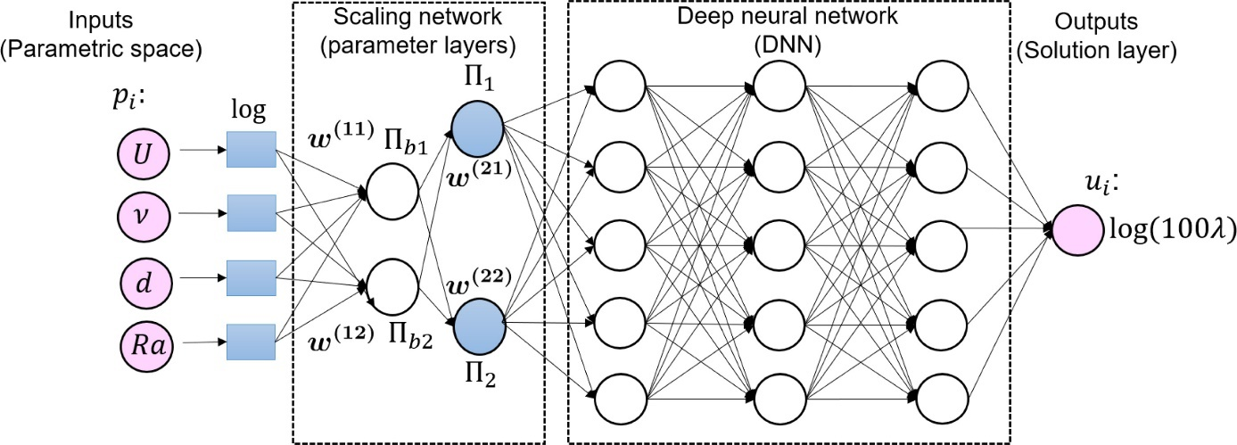
Figure 7 Architecture of Typical DNN adapted from https://www.sciencedirect.com/science/article/pii/S004578252030637X

2.5.3 Convolutional Neural Network
Convolutional Neural Networks or CNNs, are a specialized type of neural network designed for handling data with a recognizable grid-like structure. It is commonly used with image data, conceptualized as a two-dimensional grid of pixels. However, this grid topology is also applicable to various data types, such as natural language or time-series data, represented as a one-dimensional grid with samples at regular intervals.

2.5.3.1 Convolution Operation
In Mathematics, convolution of a function f and function g is a function that defines how the shape of the function f changes with the function g. The convolution of f and g is written as f∗g, denoting the convolution operator with the symbol ∗.
$$\left(f*g\right)t≔-\int_{∞}^{∞}{f\left(τ\right)g\left(t-τ\right)ⅆτ}$$ | ($SEQ Equation \backslash * ARABIC 42)$

In the language of convolutional networks, the initial component of the convolution is commonly denoted as the input, while the second component is termed the kernel. The result is labeled as the feature map.
Convolution involves utilizing the kernel, which is a small matrix representing weights for transforming input data. This kernel moves systematically across the input, conducting element-wise multiplication with local regions and summing the results to generate a singular value. The output feature map is then formed, indicating the presence of specific patterns in the input.
The convolution operation encourages parameter sharing, employing the same weights throughout the input for consistent local pattern extraction. Moreover, convolutional layers demonstrate local receptive fields and translation invariance, emphasizing small, spatially local features and recognizing patterns regardless of their position.
In CNNs, multiple convolutional layers are often stacked to progressively extract hierarchical features, making this operation fundamental for tasks like image recognition and object detection.

2.5.3.2 General Architecture
CNN is usually made of three fundamental layers: convolutional layers, pooling layers, and fully-connected (FC) layers. Stacking these layers results in the formation of a complete CNN architecture.
Beyond these core layers, two additional significant parameters are employed: the dropout layer and the activation function.
- Input Layer: Receives the input data, typically in the form of images with height, width, and channels.
- Convolutional Layers: Applies convolution operations using learnable filters to detect features in the input.
- Activation Function: Introduces non-linearity to the output of convolutional layers, commonly using ReLU. The value of a neuron in a forward pass is calculated by the following equation
$$y=\sum_{i=1}^{m}{\left(x_{i}^{*}⋅ω_{i}\right)}+b$$ | ($SEQ Equation \backslash * ARABIC 43)$
where, $x_{i}$are the input features, $ω_{i}$are the weights, and $b$ is the bias of the neuron. The activation function determines whether a neuron will be activated or not. The functions are non-linear and accept a single input.
- Pooling Layers: Reduces spatial dimensions through down-sampling or aggregation, often using max pooling.
- Fully Connected Layers: Connects every neuron in one layer to every neuron in the next layer, responsible for making predictions.
- Flattening: Converts multi-dimensional output from previous layers into a one-dimensional vector before passing to fully connected layers.
- Output Layer: Produces the network's final output, typically class probabilities for tasks like image classification.
- Dropout Layers: sometimes added to prevent overfitting by randomly dropping neurons during training.
- Batch Normalization: Normalizes inputs of a layer to improve training stability and speed.

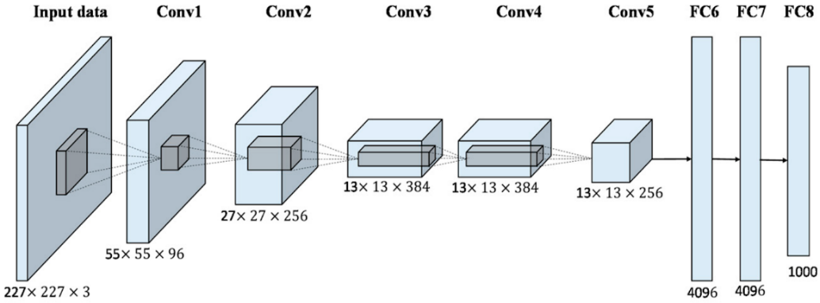

Figure 8 Architecture of AlexNet, used for image recognition and classification adapted from https://papers.nips.cc/paper_files/paper/2012/hash/c399862d3b9d6b76c8436e924a68c45b-Abstract.html
  - Machine Learning and Material Modelling
The use of neural networks to model anisotropy in multiscale models is an area of active research in materials science and engineering. Multiscale models are important for accurately capturing the behaviour of anisotropic materials, as they can account for the complex microstructures and physical mechanisms that give rise to anisotropy.
One approach to using neural networks in multiscale modelling is to develop hybrid models that combine atomistic or molecular dynamics simulations with continuum models. Researchers have used datasets obtained from molecular dynamics simulations to train ANNs that can approximate unambiguous state functions, such as the elastic stress–strain relation (tensor equation of state), the dislocation nucleation threshold, the void nucleation threshold and the beginning of bcc transformation. (11)
Another approach is to use neural networks to develop surrogate models that can replace more computationally expensive models, such as finite element models. GNN Surrogate models can be trained to predict the grain-scale elastic response of polycrystalline metallic alloys and can provide accurate predictions at a fraction of the computational cost of traditional models. (12)
Additionally, researchers are exploring the use of neural networks to develop data-driven models that can capture the anisotropic behaviour of materials at different length scales. For example, researchers have used neural networks to predict the mechanical properties of polycrystalline materials based on the crystallographic orientations of the individual grains, and have shown that these predictions can be used to develop accurate multiscale models. (13)
Overall, the use of neural networks in multiscale modelling of anisotropy is a rapidly developing area of research, and has the potential to greatly improve our understanding of the behaviour of anisotropic materials in various applications.

3 Methodology
The integration of machine learning into crystal plasticity models is particularly advantageous for the modelling of anisotropic materials. Traditional crystal plasticity models demand a deep understanding of intricate crystallographic orientations and material behaviours, often requiring extensive calibration. ML revolutionizes this process by using large datasets, allowing the model to autonomously learn complex patterns without the need for complex manual calibration.
It is a data-driven approach that enhances predictive accuracy while also addressing the computational complexity associated with anisotropic material simulations. It efficiently captures nonlinear responses and adapts to diverse material behaviours. Furthermore, the transferability of machine learning models across similar materials streamlines the modelling process and enables more versatile applications.
Because of the challenges associated with computational simulation of Crystal Plasticity, this paper investigates the application of Convolutional Neural networks in material modelling to achieve similar results as Crystal Plasticity simulations.

3.1 Data Generation
This study employed DAMASK (Düsseldorf Advanced Material Simulation Kit), a simulation too for modelling crystal plasticity on multiscale level, to investigate the mechanical behaviour of a Face-Centred Cubic (FCC) 50-grain AA5083 RVE. A comprehensive set of 245 simulations were conducted, each capturing distinct states of the crystal undergoing various loading conditions. The simulations span 100 timesteps, providing a detailed temporal evolution of the crystal's response to diverse loading scenarios. The output of each simulation was stored in Hierarchical Data Format (HDF5) files, encompassing critical information such as phases, homogenization data, and the applied material model, along with geometric attributes.
During the simulation the RVE was divided into a 16x16x16 cellular structure, where each cell is associated with a grain and contains its properties which includes deformation gradient, orientations and stresses. Therefore, there are 4096 cells and 4913 nodes encasing 50 grains.

3.2 Data Extraction
To extract meaningful information from DAMASK simulation results, a custom Python script was developed. The script utilizes the h5py library to interact with HDF5 files and leverages NumPy for efficient numerical operations.

3.2.1 Initialization
The simulation results are stored in a set of HDF5 files, each corresponding to a specific increment of the simulation. The script initializes matrices to store deformations, stresses, and orientations for further processing.

3.2.2 Data Processing Loop
The script iterates through each HDF5 file, processing increments sequentially. For the first increment (key == "increment_0"), unique orientations are computed and arranged. Grain indices are assigned based on these unique orientations, and initial orientations are averaged for each grain. It is worth noting that these unique orientations are in the quaternion form and the quaternion averaging is done to obtain the average of different orientations of the same grain in subsequent increments.

3.2.3 Subsequent Increments
For subsequent increments, the script computes average deformations, stresses, and orientations for each grain and assigns this information to all the cells associated with this grain. Processed data, including deformations per grain, stresses per grain, and new orientations per grain, is stored in a new HDF5 file under different groups named "increment_0," "increment_1," and so on. The data is extracted while also preserving the original structure of the grain.

3.2.4 Data Storage
The processed data is stored in a new HDF5 file named "extracted_data.h5," which serves as the consolidated dataset for further analysis. The extracted data consists of 24500 increments, each increment containing a 16x16x16 cellular cube, with each cell holding the information about the properties of the grain assigned to it.

3.3 Data Pre-Processing
Data scaling is the process of reducing the range of data to a desired range so as to prevent a feature from dominating the algorithm.
The 5d array of deformation gradient (16,16,16,3,3) and 5d array of orientations (16,16,16,1,4) act as input to the model and the 5d array of stresses produced to deformation gradient (16,16,16,3,3) and 5d array of new orientations due to deformation gradient (16,16,16,1,4) act as the output to the model.
The data obtained from simulation has large differences in magnitude. Deformation gradient has a magnitude of around ${10}^{-20}$ while the stresses have a magnitude of around ${10}^{10}$. Such a large difference in magnitudes made data scaling necessary. To overcome this, stresses were converted to MPa by dividing them by ${10}^{6}$ and then scaled to a range of (-1,1) using the Min Max scaler.
The Min Max scalar reduces the range of the dataset while also preserving the relationships between different features and preserving the order of the dataset.

3.4 CNN Model
Convolutional Neural Network was used in this study to simulate the behaviour of Crystal Plasticity due to their ability to capture spatial relationships, extract local features, and handle complex, grid-like data representations.

3.4.1 Dataset Handling
A small chunk of the dataset is separated and not used for training. This is done to find out how the model will perform on unseen dataset.
The dataset is first shuffled and then split into training, validation and test data set. The first 80% of the data is used for training. The next 10% of the dataset is used for validation and the remaining 10% for testing. The Validation dataset tracks the performance of the model parameters and is used to tune the hyperparameters so as to reach a model with the best performance. The test dataset is used to test the final model fitted on the training dataset.

3.4.2 Neural Network Architecture
The deformation gradient dataset and stresses dataset is reshaped from (16,16,16,3,3) to (16,6,16,9). Therefore, each element of the deformation gradient and stresses arrays acts as a channel. The old and new orientations have a shape of (16,16,16,4) where each orientation element acts as a channel.
The deformation gradient and old orientations are combined to form a 16x16x16 cube with 13 channels. Similarly, for the output, Stresses and new orientations were combined to obtain a 16x16x16 cube with 13 channels.
As given, there are 24500 cubes obtained from 245 files each having 100 increments. These cubes are fed to the network one by one. The network has 7 consecutive convolution block. After the dataset is passed through a convolution block, batch normalization is performed on it which recentres and rescales the dataset to make the network faster.

3.4.3 Hyperparameters
The training dataset is fed to the model in a batch size of 128. The batch size is a hyperparameter in gradient descent that regulates the quantity of training samples processed before updating the internal parameters of the model.
The learning rate of the model is set at 0.01. The learning rate serves as a tuning parameter within an optimization algorithm, dictating the size of the step taken at each iteration as the algorithm progresses towards minimizing a loss function.

3.4.4 Activation function
The activation function used in this network, is tanh. The tangent hyperbolic function is calculated by the following equation.
$$\tanh\left(x\right)=\frac{e^{x}-ⅇ^{-x}}{ⅇ^{x}+e^{-x}}$$ | ($SEQ Equation \backslash * ARABIC 44)$
The activation function is activated after batch normalization in each convolution block.

3.4.5 Training and Validation
When the model has an optimizer, Adam in this case, the training loop is fed with deformation and orientation. After the forward pass, the model returns predicted values of stress and orientation.
The model has 10 epochs which is the number of times the dataset is fed to the model for training. At the end of each epoch, Validation loss, Stress RMSE and orientation MAE were calculated.

3.4.6 Optimization
For optimization, the Adam optimization algorithm with default parameters was employed, representing a stochastic gradient descent technique that relies on adaptively estimating both first-order and second-order moments. It is used to update the weights of the network. Weight decay was set to 0.001 which is the hyperparameter for L2-regularization.
Learning rate of the algorithm was set at 0.01 An exponential learning rate decay (gamma 0.9) is used which reduces the learning rate after each epoch.

3.4.7 Evaluation criteria
The Mean Squared error loss is calculated over the entire output consisting of stresses and new orientations.
$$MSE=\frac{1}{n}\sum_{i=1}^{n}{{\left(Y_{i}-{\hat{Y}}_{i}\right)}^{2}}$$ | ($SEQ Equation \backslash * ARABIC 45)$
n = number of data points
$Y_{i}$ = observed values
${\hat{Y}}_{i}$ = predicted values
For the stresses, RMS error is calculated on the test dataset and for orientations MAE error is calculated on the test dataset
$$RMS=\sqrt{\frac{\sum_{i=1}^{N}{{\left(x_{i}-{\hat{x}}_{i}\right)}^{2}}}{N}}$$  i = variable i  N = number of data points  $x_{i}$ = actual observations  ${\hat{x}}_{i}$ = estimated observations | ($SEQ Equation \backslash * ARABIC 46)$
$$MAE=\frac{\sum_{i=1}^{n}{\left|y_{i}-x_{i}\right|}}{n}$$  $y_{i}$=prediction  $$x_{i}=true value$$  n =total number of data points | ($SEQ Equation \backslash * ARABIC 47)$

3.5 Experiments

3.5.1 Hyperparameter tuning
The hyperparameters of the model were changed and the changes in performance were observed.
The learning rate determines the speed of the model. Smaller learning rate leads to smaller change in weights, thus requiring more epochs.
Learning rates used - 0.01, 0.005
Batch size determines the size of the chunk of data that is fed to the model in each iteration. A large batch size means the model will have large gradient updates. This can lead to the model not learning the data well.
Batch sizes used- 128, 256
The number of epochs is the number of times the training dataset will go through the network. Small epoch size could lead to the network not learning the model well, while too many epochs can lead to overfitting.
Number of epochs used- 10, 20, 50

3.5.2 Addition of layers
Initially the network had 7 convolutional layers, with the first 6 layers followed by batch normalization layers. The initial model did not have any Max Pooling Layers, dropout layers and fully connected layer. However, the performance of the network was not optimum.
The network was experimented with by adding Max Pooling layers first and then adding drop out layers while removing batch normalization layer. The performance of each variant of the network was noted and studied.

4 Results and Discussion
The results of the experiments are presented in this section.

4.1 Initial Architecture
The initial architecture involved the neural network working on 7 convolutional layers with a batch normalization layer after each convolution block. This model was run on different hyperparameters, the results of which are displayed.

4.1.1 Lr = 0.01, batch size =128, Number of epochs =10
Losses | Validation Dataset | Test Dataset
Total loss | 0.020613392908126117 | 0.020519882906228304
Stress RMSE | 41.00623321533203 | 40.860260009765625
Orientations MAE | 0.11185858398675919 | 0.11216209828853607
Table 1Table 1 Comparison of Losses between Validation and Test dataset with Lr = 0.01, batch size =128, Number of epochs =10
For the validation dataset, the total loss was 0.0206, the Stress RMSE loss was 41.0062 MPa and the Orientation MAE loss was 0.1119. For the test dataset, the total loss was 0.0205, the Stress RMSE loss was 40.8603 MPa and the Orientation MAE loss was 0.1122

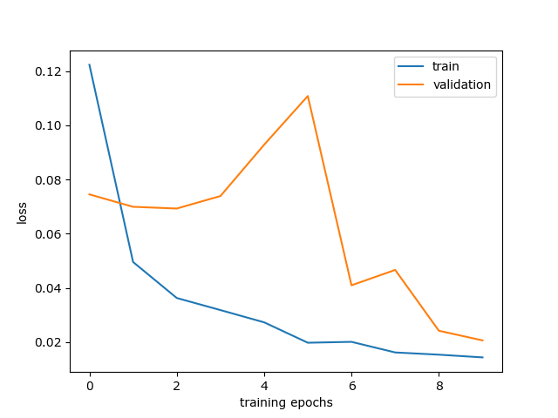
Figure 9 Training loss and Validation loss with Lr = 0.01, batch size =128, Number of epochs =10
Figure 9, shows that the training loss decrease with epochs and so did validation loss. However, validation loss has spikes in it. This shows that the network is not stable. The hyper parameters will be changed to improve the performance.
Figure 10 shows that both Stresses MSE and Orientation MAE decrease over time however, as reflected by Figure 9, the model is not stable and the error is increasing unpredictably.

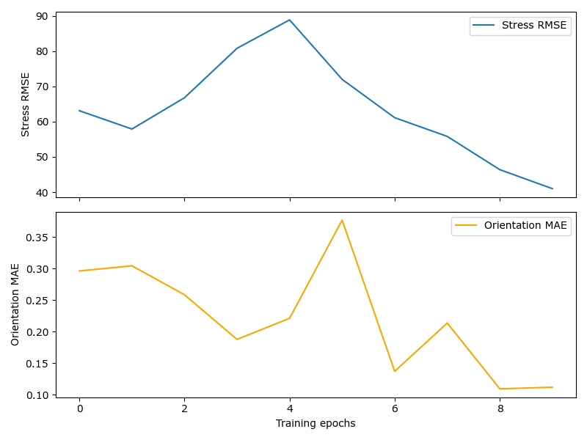
Figure 10 Stresses RMSE and Orientation MAE for Lr = 0.01, batch size =128, Number of epochs =10

4.1.2 Lr = 0.005, batch size =128, Number of epochs =10
Losses | Validation Dataset | Test Dataset
Total loss | 0.04170538708567619 | 0.04092117492109537
Stress RMSE | 53.323402404785156 | 52.55547332763672
Orientations MAE | 0.20319657027721405 | 0.20275795459747314
Table 2 Comparison between Validation and Test dataset Loss with Lr = 0.005, batch size =128, Number of epochs =10
Table 2 shows that for the validation dataset, the total loss was 0.0417, the Stress RMSE loss was 53.323 MPa and the Orientation MAE loss was 0.2032. For the test dataset, the total loss was 0.04092, the Stress RMSE loss was 52.5554 MPa and the Orientation MAE loss was 0.2027. Since the stress RMSE loss has increased significantly and the total loss and orientation MAE have increased too, a smaller learning rate did not help.
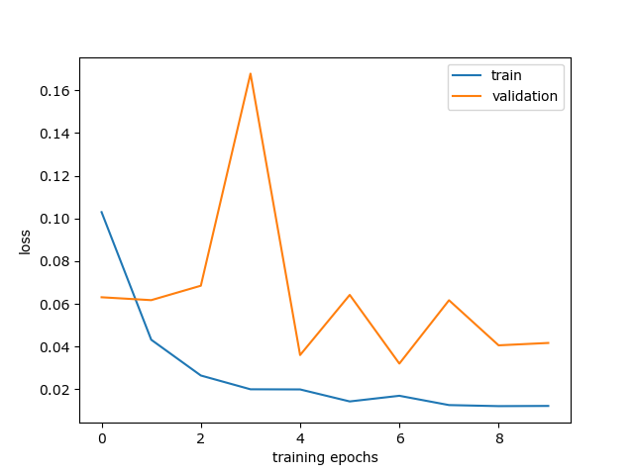
Figure 11 Training loss and Validation loss with Lr = 0.005, batch size =128, Number of epochs =10
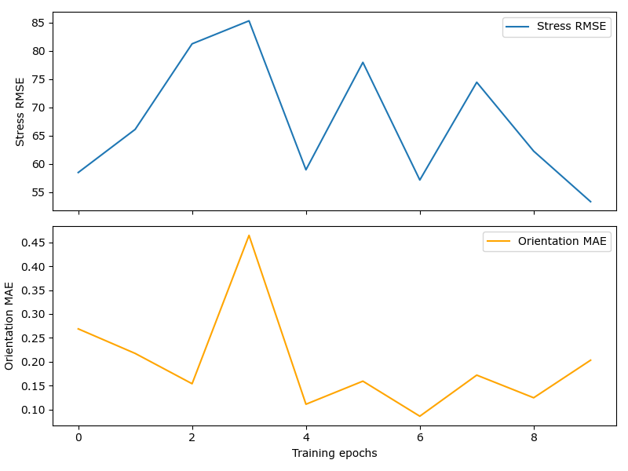
Figure 12 Stresses RMSE and Orientation MAE for Lr = 0.005, batch size =128, Number of epochs =10
Figure 11, shows that the training loss decrease with epochs but the Validation loss has not improved and there has been no decrease in spikes too. Figure 12 shows that both Stresses MSE and Orientation MAE decrease over time however there is a very large spike that makes the model unusable.

4.1.3 Lr = 0.01, batch size =128, Number of epochs =20
Losses | Validation Dataset | Test Dataset
Total loss | 0.021715279296040536 | 0.02140768188983202
Stress RMSE | 44.752845764160156 | 44.38495635986328
Orientations MAE | 0.08645022660493851 | 0.0867137536406517
Table 3 Comparison between Validation and Test dataset Loss with Lr = 0.005, batch size =128, Number of epochs =20
Table 3 shows that for the validation dataset, the total loss was 0.0217, the Stress RMSE loss was 44.7528 MPa and the Orientation MAE loss was 0.0864. For the test dataset, the total loss was 0.02141, the Stress RMSE loss was 44.6849 MPa and the Orientation MAE loss was 0.0867. Since the Orientation MAE have decreased but the total loss and Stress RMSE has not changed, the increase in epochs cannot solely improve the model.
Figure 13, shows that the training loss and validation loss have decreased with epochs however the spikes have not improved. Figure 14 shows that both Stresses MSE and Orientation MAE decrease over time and the spikes are also decreasing with epochs.
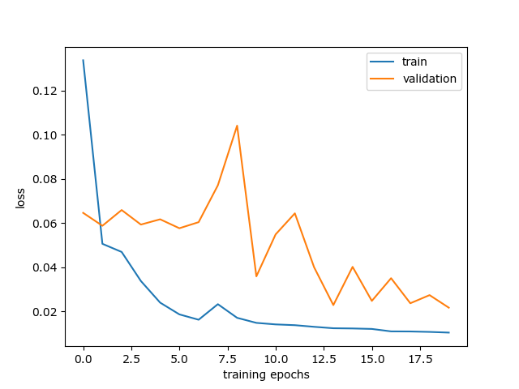
Figure 13 Training loss and Validation loss with Lr = 0.005, batch size =128, Number of epochs =20

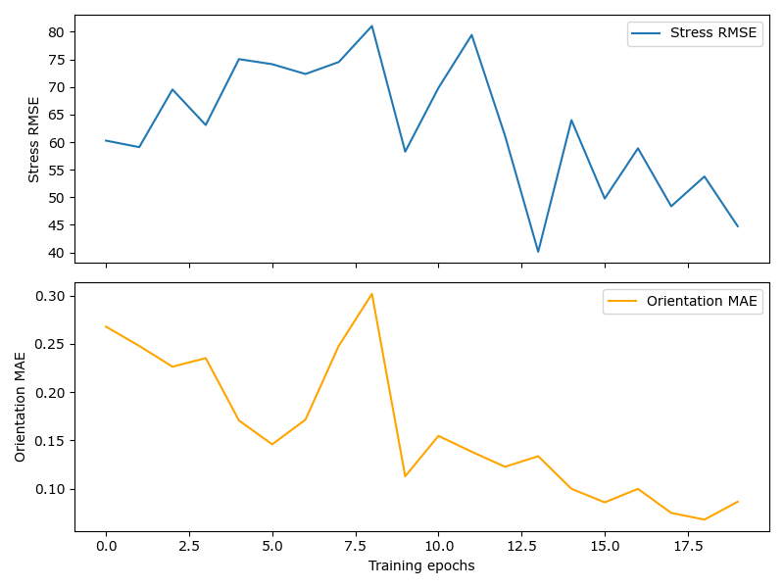
Figure 14 Stresses RMSE and Orientation MAE for Lr = 0.005, batch size =128, Number of epochs =20

4.2 Changing Train- Validation Data Split
The smooth curve of train Loss as compared to the spikes in Validation Loss indicated that the validation dataset might be too small as compared to Training Dataset.
The Training- Validation- test Dataset split was changed from 80%-10%-10% to 70%-20%-10% and the results were recorded.

4.2.1 Lr = 0.01, batch size =128, Number of epochs =15
Losses | Validation Dataset | Test Dataset
Total loss | 0.02543773803000267 | 0.025513472966849804
Stress RMSE | 52.63875198364258 | 52.742767333984375
Orientations MAE | 0.052590008825063705 | 0.05212156102061272
Table 4 Comparison between Validation and Test dataset Loss with Lr = 0.005, batch size =128, Number of epochs =15, 70-20-10 Dataset split
The number of epochs were also set at 15 to check if the network peforms decently. As shown in Table 4, both validation and test total loss are similar to the previous runs. The Stress RMSE is the same but the Orientation MAE has decreased significantly.
Figure 15 shows that the validation loss is decreasing, however it still has spikes. Figure 16 shows that Stress RMSE is not stable but Orientation MAE trend is converging. This could be fixed by adding more epochs.
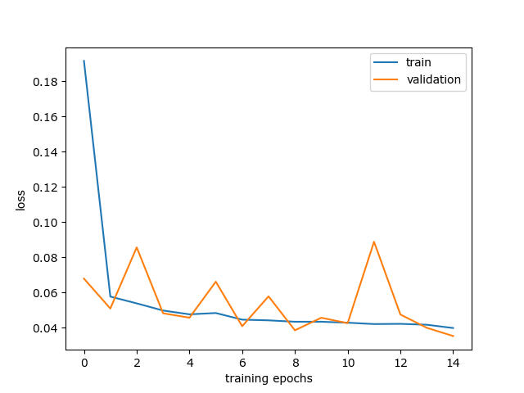
Figure 15 Training loss and Validation loss with Lr = 0.005, batch size =128, Number of epochs =15, with 70-20-10 Dataset split

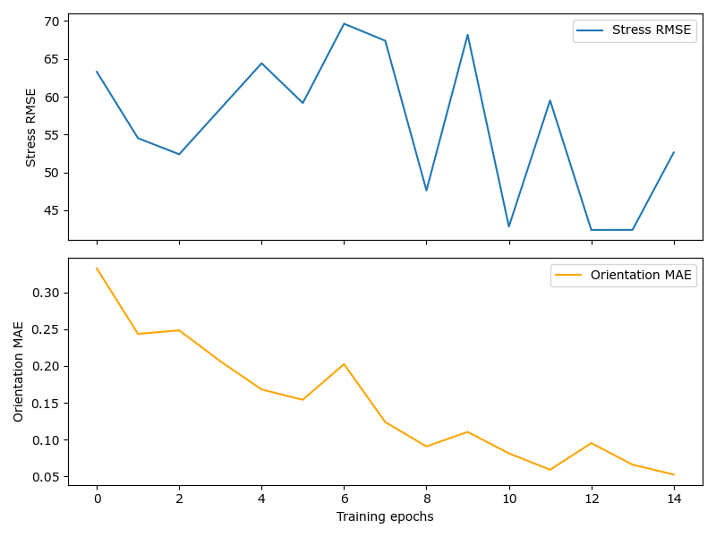
Figure 16 Stresses RMSE and Orientation MAE for Lr = 0.005, batch size =128, Number of epochs =15

4.2.2 Lr = 0.01, batch size =128, Number of epochs =30
Losses | Validation Dataset | Test Dataset
Total loss | 0.011377513790741945 | 0.01132243061438203
Stress RMSE | 35.311946868896484 | 35.26676559448242
Orientations MAE | 0.034161731600761414 | 0.03377687186002731
Table 5 Comparison between Validation and Test dataset Loss with Lr = 0.005, batch size =128, Number of epochs =25, 70-20-10 Dataset split
Number of epochs were increased by 15 in this iteration. In Table 5, Validation and Test Total loss has decreased from 0.0254 to 0.01137. Stress RMSE is also decreased by 15 MPa and, the Orientation MAE also decreased from 0.05 to 0.034.
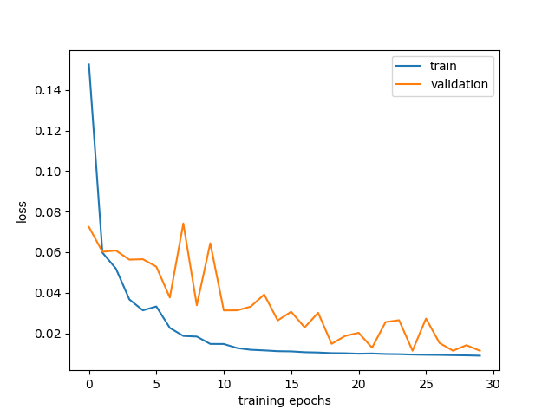
Figure 17 Training loss and Validation loss with Lr = 0.005, batch size =128, Number of epochs =25, with 70-20-10 Dataset split
Figure 17 shows that the validation loss is decreasing and the spikes have decreased significantly. According to Figure 18, the Stress RMSE and Orientation MAE trend is converging and the spikes have decreased too. A smoother curve might be attained from more epochs. However, that is out of the scope of this study due to lack of computational resources.
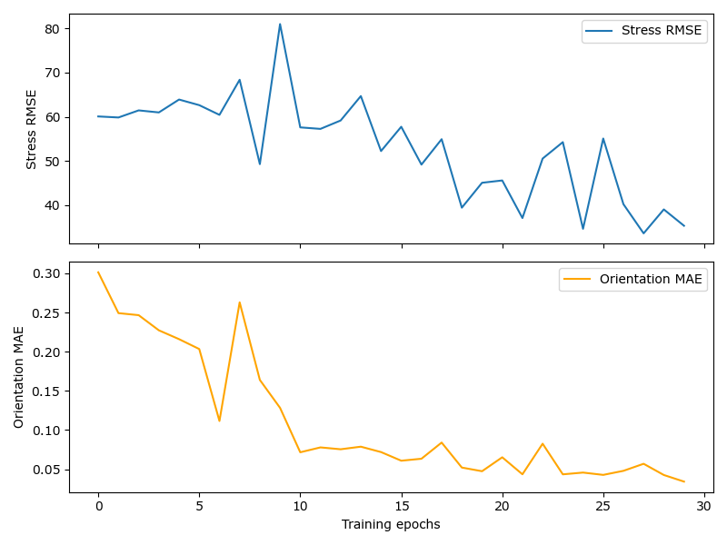
Figure 18 Stresses RMSE and Orientation MAE for Lr = 0.005, batch size =128, Number of epochs =25

4.3 Addition of Max Pooling Layer

4.4 Addition of Dropout Layer

4.4.1 Lr = 0.01, batch size =128, Number of epochs =15
Losses | Validation Dataset | Test Dataset
Total loss | 0.035247512543812774 | 0.03572798538953066
Stress RMSE | 55.14199447631836 | 55.5518684387207
Orientations MAE | 0.13151179254055023 | 0.13203275203704834
Table 4 Comparison between Validation and Test dataset Loss with Lr = 0.005, batch size =128, Number of epochs =15, 70-20-10 Dataset split
The number of epochs used were 15 to allow the network to learn the data more accurately. As shown in Table 4, both validation and test total loss have decreased significantly. The Stress RMSE also decreased by 10 MPa as compared to the previous model however, the Orientation MAE is still the same.
Figure 15 shows that the validation loss is decreasing, however it still has spikes. Figure 16 shows that Stress RMSE and Orientation MAE trend has not changed. This could be fixed by adding more epochs.
Figure 15 Training loss and Validation loss with Lr = 0.005, batch size =128, Number of epochs =15, with 70-20-10 Dataset split
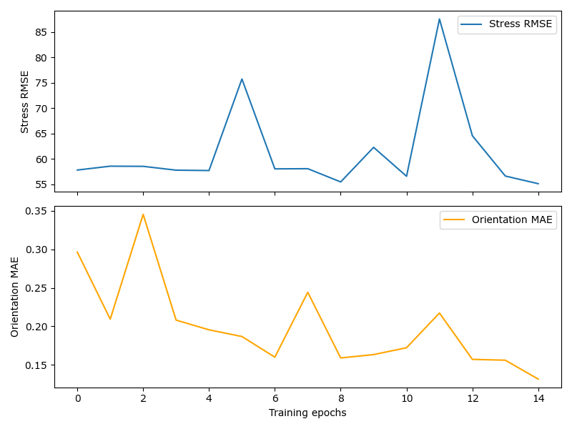
Figure 16 Stresses RMSE and Orientation MAE for Lr = 0.005, batch size =128, Number of epochs =15

4.4 Discussion
The experiment involved tuning the hyperparameters of the network to obtain parameters that runs the network at best performance. Initially the dataset was split into 80% train data, 10% test data and 10% validation data. The performance of the model at different hyperparameters using this data split was not good even after increasing the epochs. The size of validation dataset was found to be too small, because of which the dataset split was changed from 80-10-10 to 70-20-10.
The model was then run on different hyperparameters. The network performed better but there were still spikes in the loss which indicated that the network was not stable. To counter this, max pooling was added and then dropout layer were added with no batch normalization. This produced the best result.

5 Conclusion
The goal of this paper was to implement Crystal Plasticity through a Neural Network. The training Data for the Neural network was obtained from DAMASK after running Crystal Plasticity simulations on 50 grain AA5083 RVE. Convolutional Neural Network was chosen for this task because it can capture features of the dataset while also maintaining the spatial information about the features.
The network was run at different hyperparameters and changes had to be made in the datasplit to achieve an acceptable performance. The Network replicated the Crystal Plasticity simulation information with very small total loss and 40Mpa Stress RMSE and 9% Orientation MAE which is an acceptable result.
Improvements in the model can be done by adding more convolutional and pooling layers. A larger dataset would also improve the performance of the network. These were not possible in this experiment due to time and computational constraints.
Future enhancements that can be done to simulate Crystal Plasticity better can include the utilization of different CNN architectures. Transformers can be used as alternate ways of encoding the data. RNN and Transformer work well on sequential data which might prove useful.

List of Figures

Figure 1 Schematic of a Polycrystalline metallic material. The grain boundaries act as interface between grains. The movement of grains cause vacancies and atomic defects. Adapted from Microstructure and Properties of Engineering Materials Helmut Clemens, SveaMayer, and Christina Scheu. 9
Figure 2 Finite Deformation Kinematics adapted from Microstructure and Properties of Engineering Materials Helmut Clemens, SveaMayer, and Christina Scheu. 10
Figure 3 Lattice rotation in a single crystal tensile specimen adapted from Microstructure and Properties of Engineering Materials Helmut Clemens, SveaMayer, and Christina Scheu. 12
Figure 4 Plastic shear strain on a slip system adapted from Microstructure and Properties of Engineering Materials Helmut Clemens, SveaMayer, and Christina Scheu. 13
Figure 5 Kinematics of deformation of crystal adapted from Microstructure and Properties of Engineering Materials Helmut Clemens, SveaMayer, and Christina Scheu. 13
Figure 6 Kinematics of Crystal Deformation, Stretching and Spinning adapted from Microstructure and Properties of Engineering Materials Helmut Clemens, SveaMayer, and Christina Scheu. 15
Figure 7 Architecture of Typical DNN adapted from https://www.sciencedirect.com/science/article/pii/S004578252030637X 20
Figure 8 Architecture of AlexNet, used for image recognition and classification adapted from https://papers.nips.cc/paper_files/paper/2012/hash/c399862d3b9d6b76c8436e924a68c45b-Abstract.html 22
Figure 9 Training loss and Validation loss with Lr = 0.01, batch size =128, Number of epochs =10 27
Figure 10 Stresses RMSE and Orientation MAE for Lr = 0.01, batch size =128, Number of epochs =10 28
Figure 11 Training loss and Validation loss with Lr = 0.005, batch size =128, Number of epochs =10 28
Figure 12 Stresses RMSE and Orientation MAE for Lr = 0.005, batch size =128, Number of epochs =10 29
Figure 13 Training loss and Validation loss with Lr = 0.005, batch size =128, Number of epochs =20 30
Figure 14 Stresses RMSE and Orientation MAE for Lr = 0.005, batch size =128, Number of epochs =20 30
Figure 15 Training loss and Validation loss with Lr = 0.005, batch size =128, Number of epochs =15, with 70-20-10 Dataset split 31
Figure 16 Stresses RMSE and Orientation MAE for Lr = 0.005, batch size =128, Number of epochs =15 31
Figure 17 Training loss and Validation loss with Lr = 0.005, batch size =128, Number of epochs =25, with 70-20-10 Dataset split 32
Figure 18 Stresses RMSE and Orientation MAE for Lr = 0.005, batch size =128, Number of epochs =25 32

References
1. Javier Segurado, et al. Advances in Applied Mechanics. 2018.
2. Mouritz, Adrian P. Introduction to Aerospace Materials . 2012.
3. Deformation of Single Crystals, Polycrystalline Materials, and Thin Films: A Review. Park, Guijun Yang and Soo-Jin. 2019, Materials (Basel).
4. Materials, Micromechanics of Composite. Jacob Aboudi, Steven M. Arnold and Brett A. Bednarcyk. 2013.
5. Böhm, Helmut J. Mechanics of Microstructured Materials. s.l. : Springer, 2004.
6. Crystal-plasticity finite-element analysis of anisotropic deformation behavior in a commercially pure titanium Grade 1 sheet. Takayuki Hama, Akihiro Kobuki, Hirohiko Takuda. s.l. : International Journal of Plasticity, 2017.
7. Study of Anisotropic Plastic Behavior in High Pressure Torsion of Aluminum Single Crystal by Crystal Plasticity Finite Element Method. Peitang Wei, Cheng Lu, Huaiju Liu, Lihong Su, Guanyu Deng and Kiet Tieu. s.l. : Crystals, 2017.
8. Crystal Plasticity Analysis Using Fast Fourier Transform Numerical Scheme. BACROIX, Takayuki OTSUKA Renald BRENNER Brigitte. 2018.
9. Multiscale crystal plasticity finite element model for investigating the irradiation hardening and defect evolution mechanism of A508-3 steel. Pandong Lin, Junfeng Nie, Meidan Liu. s.l. : Nuclear Materials and Energy, 2022.
10. Hybrid Micro-Macro-Modeling of Evolving Anisotropies and Length Scales in Finite Plasticity of Polycrystals. Ilona Frankenreiter, Daniele Rosato, Christian Miehe. 2011.
11. Incipience of Plastic Flow in Aluminum with Nanopores: Molecular Dynamics and Machine-Learning-Based Description. Alexander E. Mayer, Polina N. Mayer, Mikhail V. Lekanov, Boris A. Panchenko. 2022.
12. Graph Neural Network Modeling of Grain-scale Anisotropic Elastic Behavior using Simulated and Measured Microscale Data. Darren C. Pagan, Calvin R. Pash, Austin R. Benson, Matthew P. Kasemer. 2022.
13. Graph neural networks for an accurate and interpretable prediction of the properties of polycrystalline materials. Minyi Dai, Mehmet F Demirel, Yingyu Liang, Jia-Mian Hu. 2021.

